**Project Report**

**Cross-selling of Insurance Products using Predictive Analytics**

**TEAM 3**

**Team Leader:**

G Pranava Sai 21R11A0515

**Team Members:**

A Harshith Sai 21R11A0504

G Harshit 21R11A0519

P Rohith 21R11A0537

**Exploratory Data Analysis**

**1. Count of Responses**

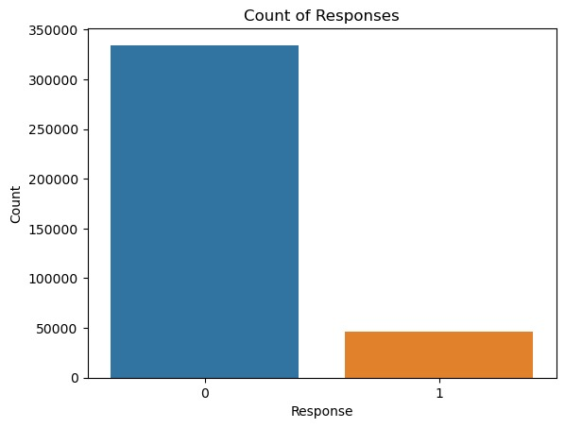

**Observation:**

1. Form the above bar plot we can easily say that most of the people are not interested in the insurance verry less number of people are interested

**2.Response Rate by Gender**

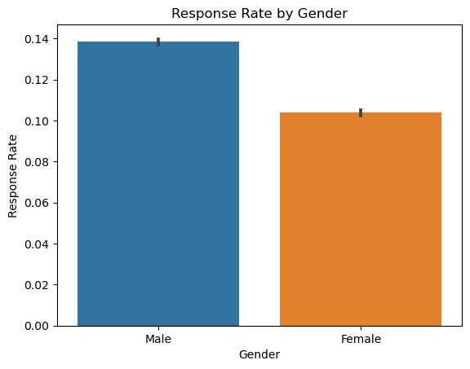

**Observation:**

from the above graph we can say mainly most of the responses rate by gender.The male response rate is slightly higher than the female response rate.Both bars have error lines at their tops, indicating a range of values.

**3.Heatmap**

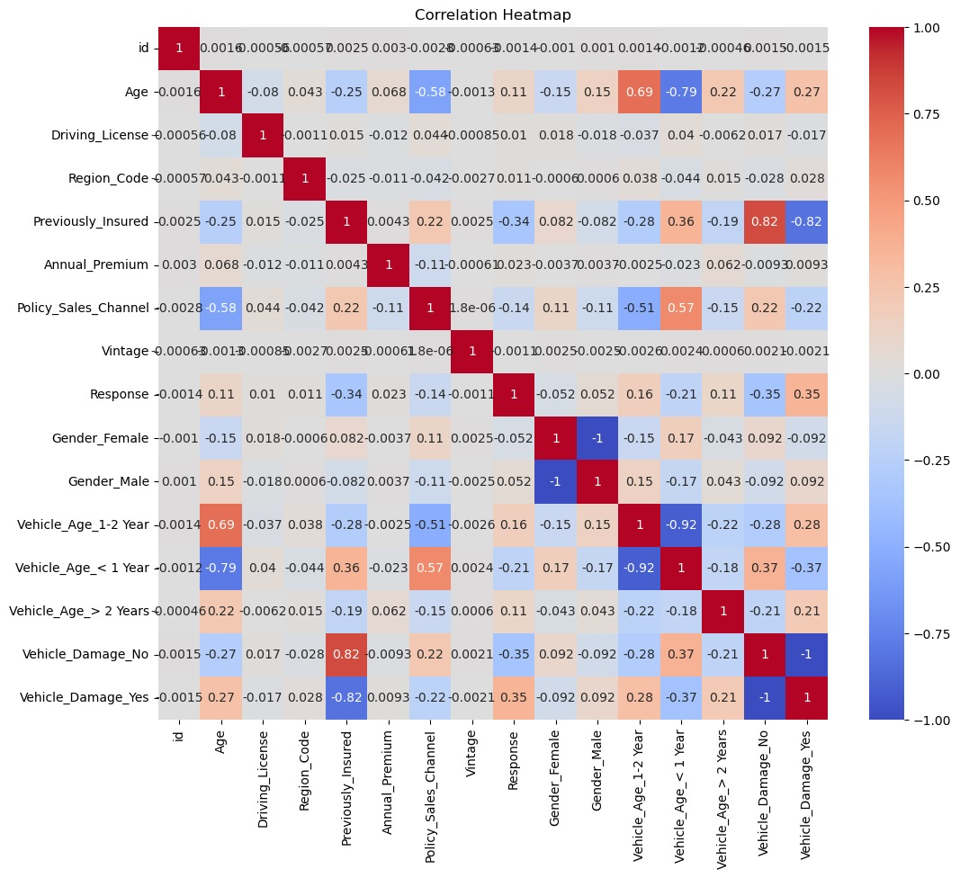

**Observation**from given heatmap we can say that Age correlates positively with annual premium, and previously insured customers are less likely to respond positively . Negative Correlations: No strong negative correlations are evident in the heatmap . The distribution of Annual Premium is heavily skewed towards lower values, and the Age vs. Vintage scatter plot shows no clear pattern.

Based on the provide data and the output from the Cross-selling of Insurance Products using Predictive Analytics in AZURE ML studio the following are the given test outputs:

**Transaction 1:**

Gender: Male

Age: 76

Driving License: Yes

Region Code: 3

Previously Insured: No

Vehicle Age: 1-2 Years

Vehicle Damage: No

Annual Premium: $33,536

Policy Sales Channel: 26

Vintage: 183 days

Response: No

Scored Labels: No

Scored Probabilities: 2.99%

**Analysis:**

* The customer is an elderly male (age 76) with no previous insurance and no vehicle damage.
* The annual premium seems relatively high compared to other transactions.
* The customer hasn't responded positively to the insurance offer.
* The probability of the customer responding positively is very low, indicating a low likelihood of conversion.
* Given the high age and lack of response, this transaction might not be the most favorable.

**Transaction 2**:

Gender: Male

Age: 47

Driving License: Yes

Region Code: 28

Previously Insured: N/A

Vehicle Age: > 2 Years

Vehicle Damage: Yes

Annual Premium: $38,294

Policy Sales Channel: 26

Vintage: 27 days

Response: Yes

Scored Labels: No

Scored Probabilities: 36.89%

**Analysis:**

* The customer is a middle-aged male (age 47) with a vehicle aged more than 2 years and a history of vehicle damage.
* The annual premium is higher, possibly due to the age of the customer's vehicle and previous damage.
* The customer has responded positively to the insurance offer, with a high probability of conversion.
* Despite the short vintage (27 days), the customer seems interested in the insurance offer.
* This transaction appears promising due to the positive response and high probability of conversion.

**Transaction 3:**

Gender: Male

Age: 21

Driving License: Yes

Region Code: 11

Previously Insured: Yes

Vehicle Age: < 1 Year

Vehicle Damage: No

Annual Premium: $28,619

Policy Sales Channel: 152

Vintage: 203 days

Response: No

Scored Labels: No

Scored Probabilities: 0.05%

**Analysis:**

* The customer is a young male (age 21) with a relatively low annual premium.
* The customer has a history of being previously insured and owns a vehicle aged less than a year with no damage history.
* Despite the long vintage (203 days), the customer hasn't responded positively to the insurance offer.
* The probability of the customer responding positively is extremely low.
* This transaction may not be the best due to the low probability of conversion and lack of response.

**Transaction 4:**

Gender: Female

Age: 29

Driving License: Yes

Region Code: 41

Previously Insured: Yes

Vehicle Age: < 1 Year

Vehicle Damage: No

Annual Premium: $27,496

Policy Sales Channel: 152

Vintage: 39 days

Response: No

Scored Labels: No

Scored Probabilities: 0.04%

**Analysis:**

* The customer is a young female (age 29) with a relatively low annual premium.
* Similar to Transaction 3, the customer has a history of being previously insured and owns a vehicle aged less than a year with no damage history.
* Despite the short vintage (39 days), the customer hasn't responded positively to the insurance offer.
* The probability of the customer responding positively is extremely low, similar to Transaction 3.
* This transaction may also not be the best due to the low probability of conversion and lack of response.

**Conclusion:**

* Transaction 2 stands out as the most promising among the four transactions.
* The customer in Transaction 2 is middle-aged, with a vehicle aged more than 2 years and a history of vehicle damage, indicating a potential higher level of interest in insurance coverage.
* This customer has responded positively to the insurance offer with a high probability of conversion (36.89%).
* The positive response coupled with the customer's profile suggests a greater likelihood of engagement and potential profitability.
* Therefore, focusing on Transaction 2 may yield the best results in terms of conversion and overall success.